**Java Date and Time**

<https://www.hackerrank.com/challenges/java-date-and-time/problem>

The [Calendar class](https://docs.oracle.com/javase/7/docs/api/java/util/Calendar.html) is an abstract class that provides methods for converting between a specific instant in time and a set of calendar fields such as YEAR, MONTH, DAY_OF_MONTH, HOUR, and so on, and for manipulating the calendar fields, such as getting the date of the next week.

You are given a date. You just need to write the method, getDay, which returns the day on that date. To simplify your task, we have provided a portion of the code in the editor.

For example, if you are given the date August 14th 2017, the method should return MONDAY as the day on that date.

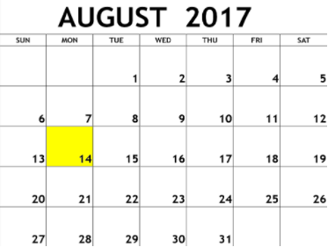

**Input Format**

A single line of input containing the space separated month, day and year, respectively, in MM DD YYYY format.

**Constraints**

* 2000 < year < 3000

**Output Format**

Output the correct day in capital letters.

**Sample Input**

08 05 2015

**Sample Output**

WEDNESDAY

**Explanation**

The day on August 5th 2015 was WEDNESDAY.